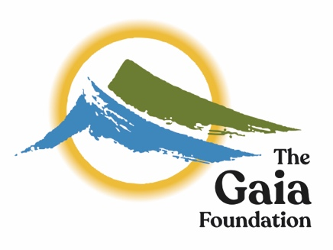

Confidential Application - Technical & Programme Support
for the Seed Sovereignty Programme

Please complete this brief application form and attach a CV outlining your career to date, plus any academic and professional qualifications. Also include details of any voluntary post undertaken. Please send your application, by 5pm on 14 April 2022, to sinead@gaianet.org
Full Name:
Address:
Mobile Phone:
Home Phone:
Email:

How did you hear of this post?

Are you eligible to work in the UK? :

REFERENCES

Please give details of two professional referees - your current employer (they will not be contacted prior to an offer), and your previous employer or personal referee:-

1 - Name and professional relationship to you:
Tel:
Email:
OK to approach Yes / No

2 - Name and relationship to you:
Tel:
Email:
OK to approach Yes / No

Current Employment Terms Details

Basic Annual Salary: Annual Leave:

Pension: Employer contribution: Employee contribution:

Any other benefits?:

Notice required: If applicable

Please state – on no more than 2 pages:

1) Why you would like to support the Seed Sovereignty Programme?

2) What three key areas of your experience and skills you can bring to this role?

(Please draw upon the job description to inform your answer and ensure at least one relates to your technical competency)

DECLARATION

I declare that the information that I have provided on this form is true and accurate, and in particular that I have not omitted any fact which may have a bearing on my application. I understand that any subsequent contract of employment with the Gaia Foundation will be made on the basis of the information I have provided. Furthermore, I understand that a false declaration, which results in my appointment to the Gaia Foundation, will render me liable to dismissal without notice.

Signature

Timetable

Deadline for applications | 5pm, Thursday 14th of April
Interview Date (Time to be arranged) | Thursday 28th of April

Further Information
If you require any further information or you would like to discuss anything in more detail, please contact Sinéad at sinead@gaianet.org or take a look at the dedicated programme website www.seedsovereignty.info
PRIVACY NOTICE: please read and tick the relevant box

As part of any recruitment process, Gaia collects and processes personal data relating to job applicants. Gaia is committed to being transparent about how it collects and uses that data and to meeting its data protection obligations.

Gaia collects a range of information about you through the application forms and CVs. This includes:
- your name, address and contact details, including email address and telephone number;
- details of your qualifications, skills, experience and employment history;
- information about your current level of remuneration, including benefit entitlements;
- whether or not you have a disability for which the organisation needs to make reasonable adjustments during the recruitment process; and
- information about your entitlement to work in the UK

Data will be stored in a range of different places, including on your application record, in HR management systems and on other IT systems (including email).

Processing data from job applicants allows us to manage the recruitment process, assess and confirm a candidate’s suitability for employment and decide to whom to offer a job. We may also need to process data from job applicants to respond to and defend against legal claims.

If your application is unsuccessful, Gaia may keep your personal data on file in case there are future employment opportunities for which you may be suited. We will ask for your consent before we keep your data for this purpose, and you are free to withdraw your consent at any time.

Please note that your information may be shared internally for the purposes of the recruitment exercise.

We will not share your data with third parties, unless your application is successful, and we make you an offer of employment. We will then share your data with former employers to obtain references for you.

We take security of your data seriously. We have internal policies and controls in place to ensure that your data is not lost, accidentally destroyed, misused or disclosed.

If your application for employment is unsuccessful, Gaia will hold your data on file for 6 (six) months after the end of the relevant recruitment process. If you agree to allow us to keep your personal data on file, we will hold your data on file for a further 6 (six) months for consideration for future employment opportunities. At the end of that period, or once you withdraw your consent, your data is deleted or destroyed.

If your application for employment is successful, personal data gathered during the recruitment process will be transferred to your Human Resources file (electronic and paper based) and retained during your employment. The periods for which your data will be held will be provided to you in a new privacy notice.

I give / I do not give Gaia consent to hold my personal details contained through the recruitment process for the full 12 months in order to be considered for other positions or not.

